

Derived state is simply state that is computed from another existing piece of state or also from props.

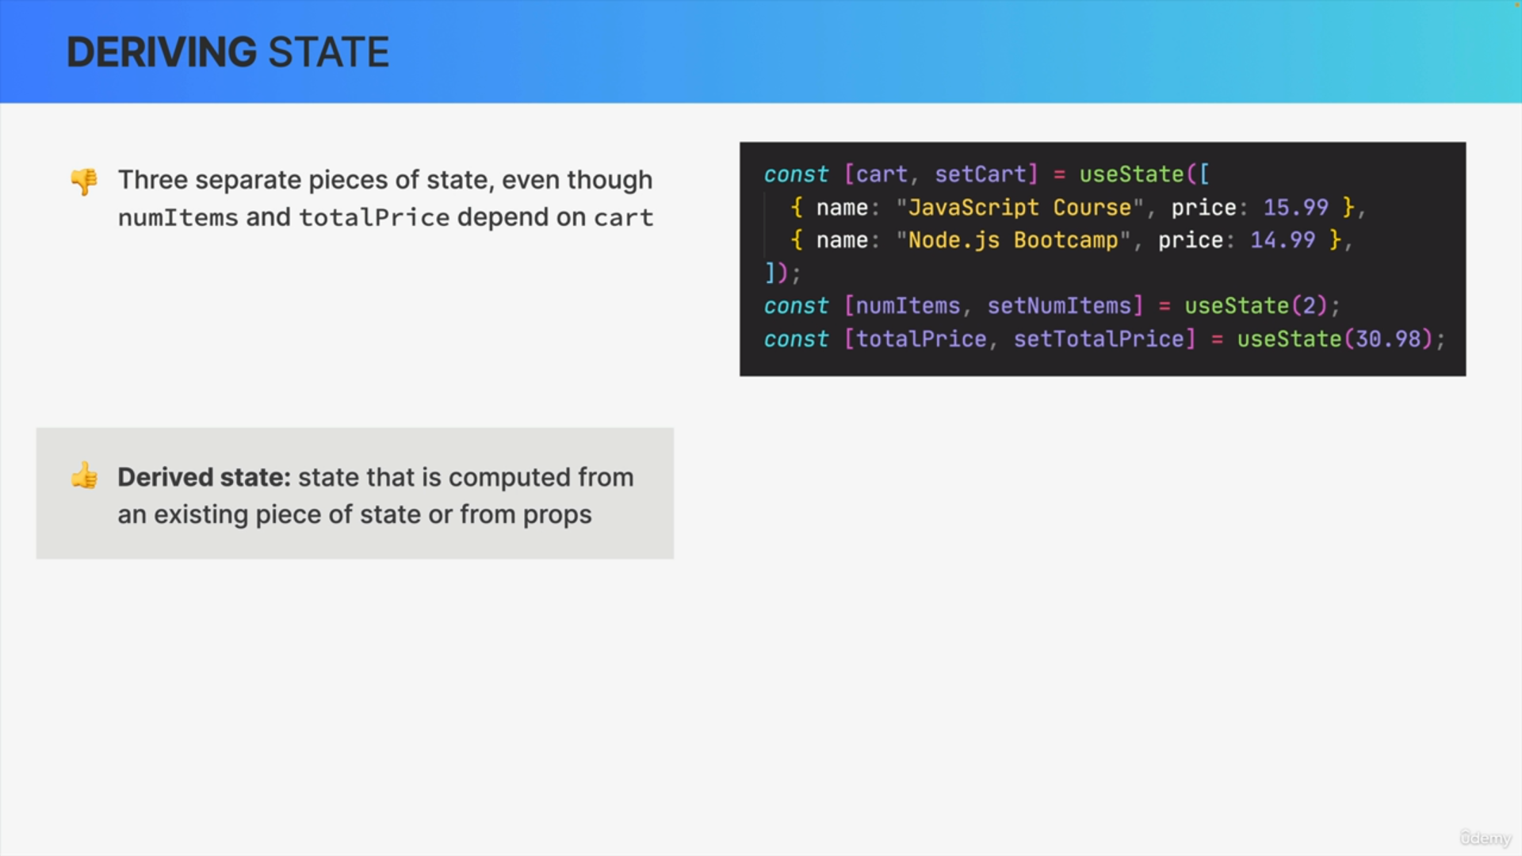

Here, we have three pieces of state as we can see by the three use state function calls.

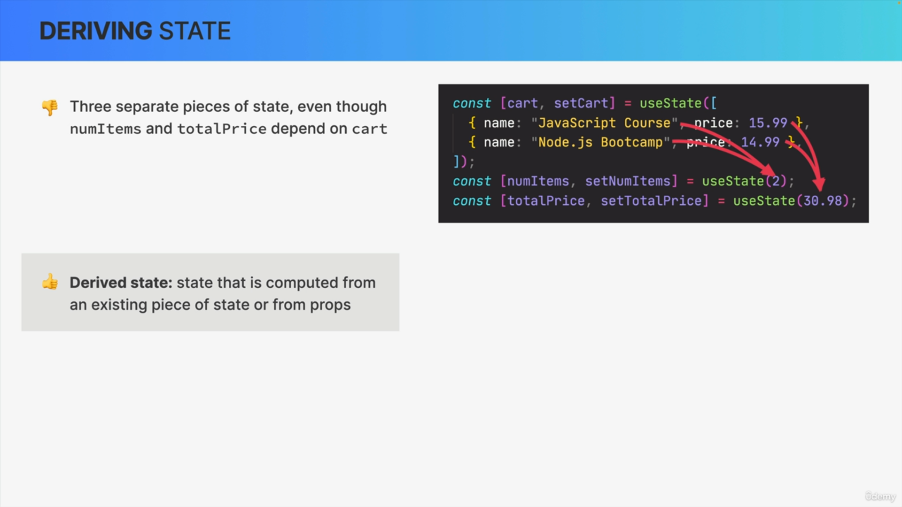

However, if we analyze these states, it actually doesn't make much sense that all of them exist because numItems and totalPrice depend entirely on the cart. So, numItems is simply the number of items in the cart and totalPrice is the sum of all the prices in the cart.

All the data for these two pieces of state is actually already in the cart. So, there's no need to create these additional state variables.

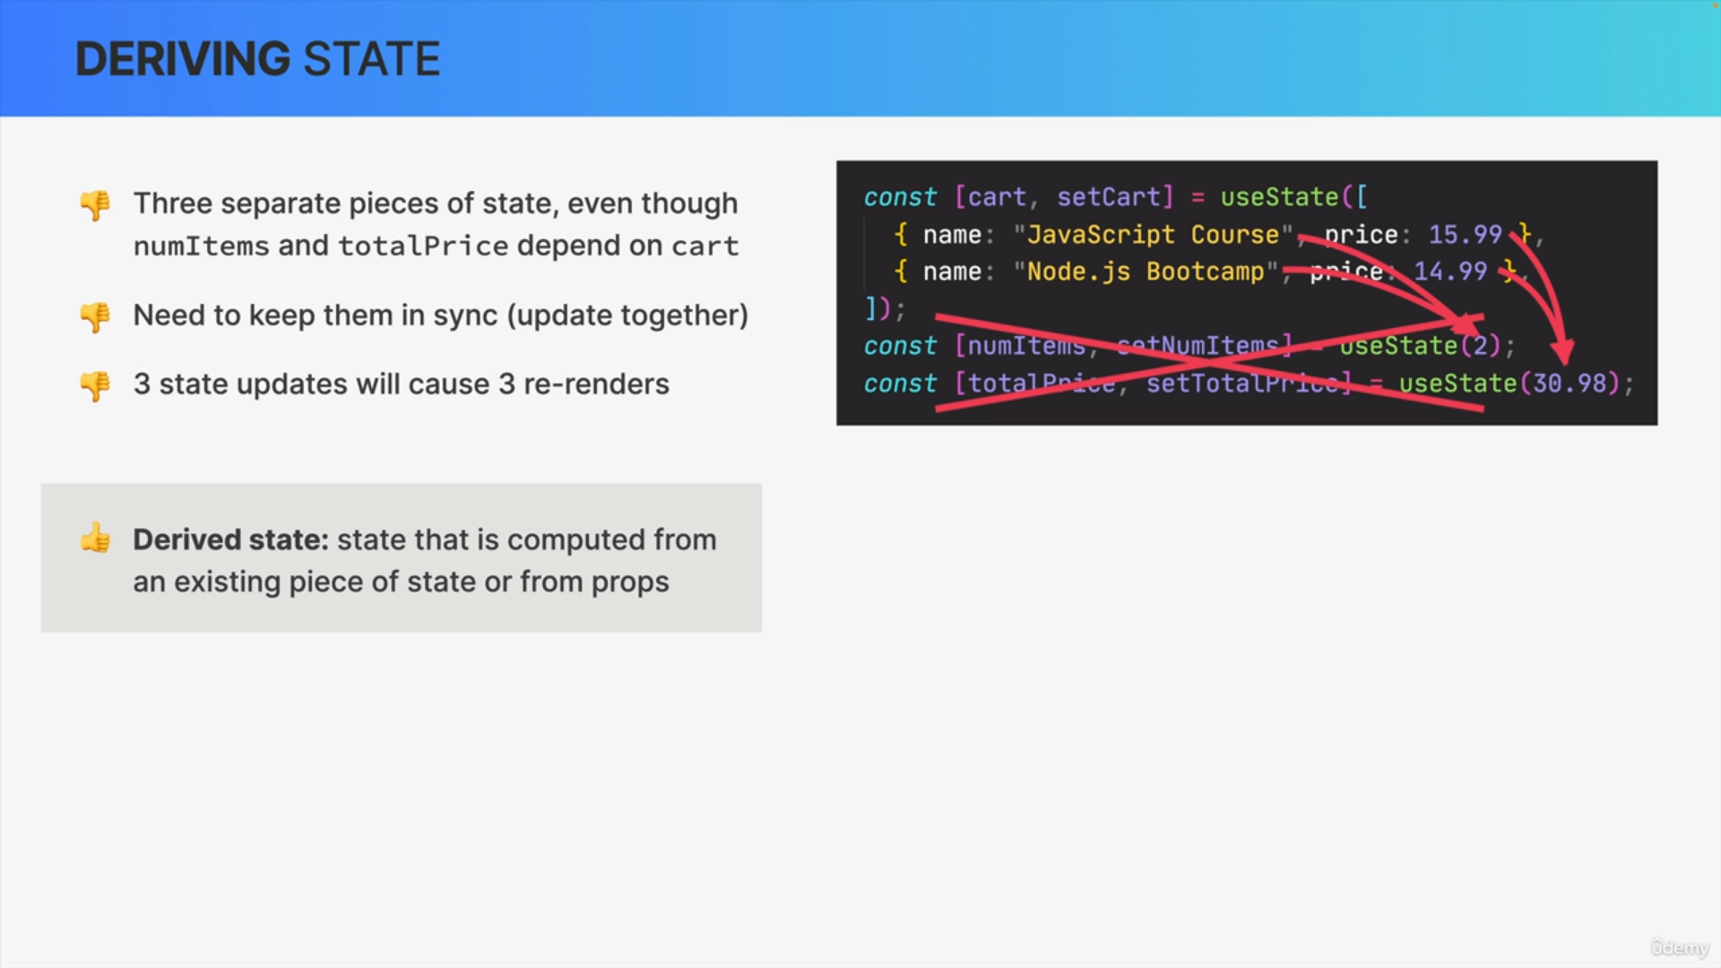

Doing so is actually quite problematic.

1. First, because now we have to keep all these states in sync. So, we need to be careful to always update them together. So, in this situation, whenever we update the cart, we will also need to manually update the number of items and the total price. Otherwise, our states would get out of sync.
2. Updating these three states separately creates a second problem because that will then re-render the component three times which is absolutely unnecessary in this example.

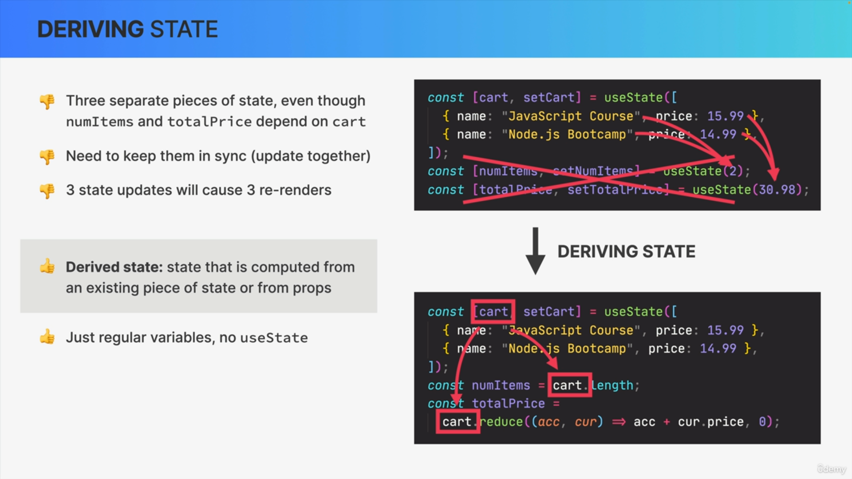

Instead, we can simply derive the numItems and totalPrice state from the cart and therefore solve all these problems because the cart already contains all the data that we need.

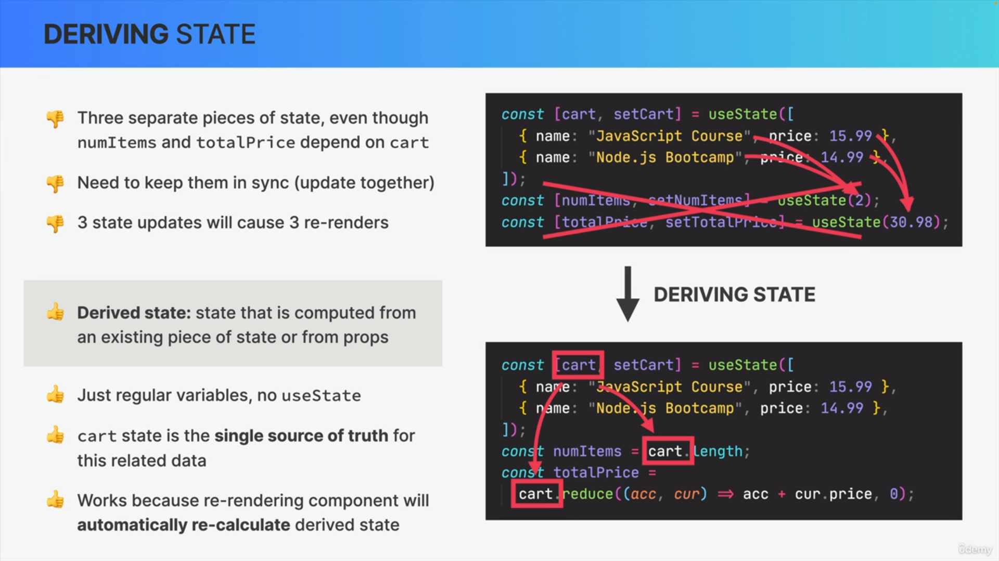

So here, we simply calculate numItems as the cart length and totalPrice as the sum of all prices and store them in regular variables. There is no useState required here which will cause no unnecessary re-renders.

The cart state acts as a single source of truth for these related pieces of state making sure that everything will always stay in sync.

This works because updating the cart will re-render the component which means that the function is called again.

So then, as all the code is executed, again, numItems and totalPrice will also, automatically, get recalculated.